Exercise 10
- Display the sum of ages of employees working at Bignet.
Answer: SELECT SUM(age) AS total_age_sum
FROM employee_data;
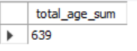

- How would you calculate the total of years of service the employees of Bignet have in the company?
Answer: SELECT SUM(years_of_service) AS total_years_of_service
FROM employee_data;
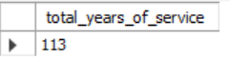

- Calculate the sum of salaries and the average age of employees who hold "Programmer" title.
Answer: SELECT
SUM(salary) AS total_programmer_salary,
AVG(age) AS average_programmer_age
FROM employee_data
WHERE title LIKE '%Programmer%';
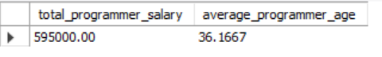

- What do you understand from the following statement?
SELECT (SUM(perks) / SUM(salary)) * 100
FROM employee_data;
Answer: The statement calculates the percentage ratio of total perks to total salary across all employees.

